|  |  |  |  |  |
| --- | --- | --- | --- | --- |
| **National University of Computer and Emerging Sciences, Lahore Campus** | | | | |
| C:\Users\saif\AppData\Local\Microsoft\Windows\Temporary Internet Files\Content.Word\final design.jpg | **Course Name:** | **Design and Analysis of Algorithms** | **Course Code:** | **CS2009** |
| **Degree Program:** | **BSCS, BSSE** | **Semester:** | **SPRING 2023** |
| **Exam Date:** | **Tuesday, April 11, 2023** | **Total Marks:** | **11 + 19 = 30** |
| **Section:** | **ALL** | **Page(s):** | **3** |
| **Exam Type:** | **Mid-Term - II** |  |  |
| **Student : Name:_____________________________ Roll No.________________ Section:_______** | | | | |
| **Instruction/Notes:** | Attempt all questions. There are two questions, don’t forget to check the back side as well. | | | |

**Question 1:** [3 + 8 = 11 Marks]

1. Draw **recursion tree** of **MyAlgo** using n = 5.

Only the recursion tree is required. No calculations are needed. **There will be no partial credit for this part.**

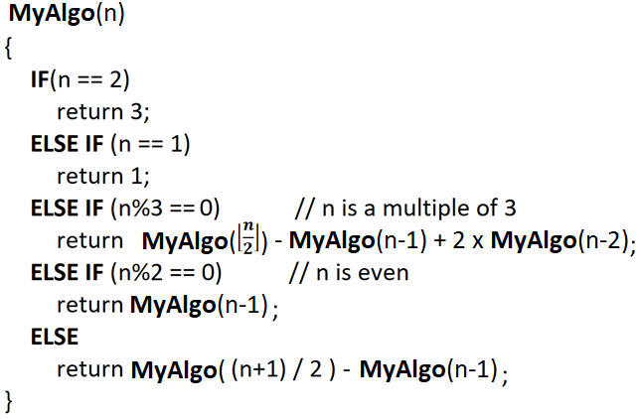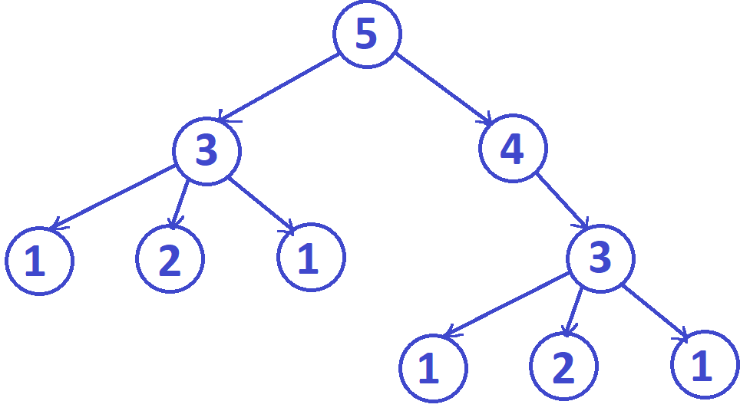

1. Convert the pseudocode given above (in part **a**) into bottom-up dynamic programming (iterative code). For this part only **pseudocode** is required.

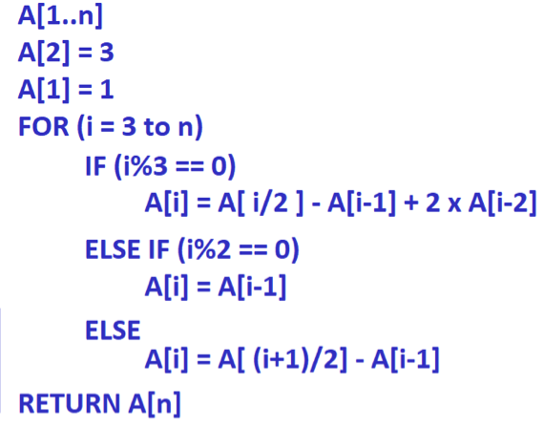

**Question 2:**

Assume that there is a moving object of pacman in a weighted grid of (N rows and M columns). Pacman starts from the cell (1,1) and can move a maximum distance of 1 unit cell at a time either in rightwards, downwards or in the diagonal cell, as shown in the figure below. Note that the object can only move forward and there is no way back. At each move pacman can score some points. These points for each move is stored in the array W[1…N][1…M].

If pacman is at cell (1, 1), it can move towards rightwards to cell (1, 2) and earn 4 points which is stored in W[1][1].**right**, or it can move downwards to cell (2, 1) and earn 7 points which is stored in W[1][1].**down** or it can move diagonally to cell (2, 2) and earn 6 points which is stored in W[1][1].**diagonal**. Pacman wants to earn maximum points while going from cell (1,1) to cell (N,M).

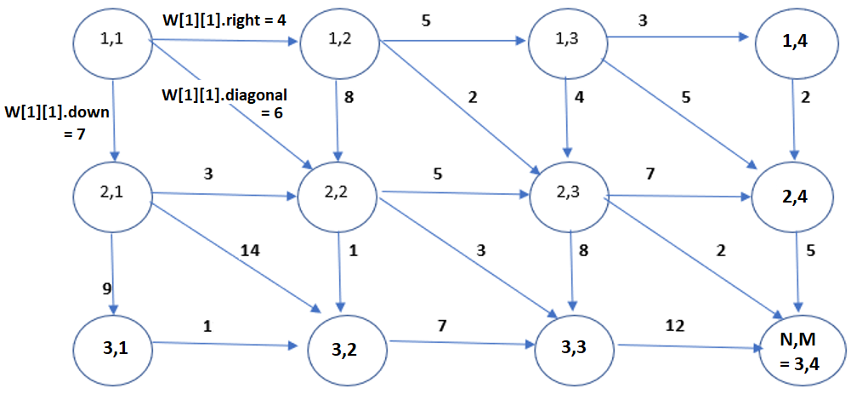

1. **COUNTER-EXAMPLE** [CLO-3] [7 marks]

Consider the greedy algorithm where pacman selects the maximum value among right, down and diagonal from each cell and move in that direction until it reach the cell (N, M), for example at cell (1, 1), pacman will move down because W[1][1].**down** is greater than W[1][1].**right** and W[1][1].**diagonal**.

Prove that the greedy algorithm is not correct by providing a counter example.

Only a counter example is required. **There will be no partial credit for this part**. The size of your counter-example should not be larger than 3 x 3.

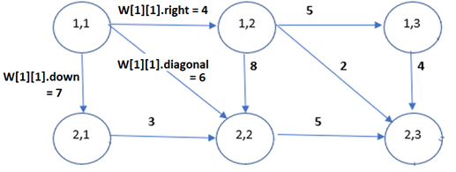

1. **Dynamic Programming** [CLO-1] [12 marks]

Design and bottom-up dynamic programming algorithm (iterative algorithm) that calculates the maximum score pacman can achieve starting from the source cell (1,1) to destination cell (N,M). Weights of edges are given in a 2-D array W[1..N][1…M]. Each entry of this array holds three values i.e. W[i][j].right, W[i][j].down and W[i][j].diagonal. For this part only **pseudocode** is required.

